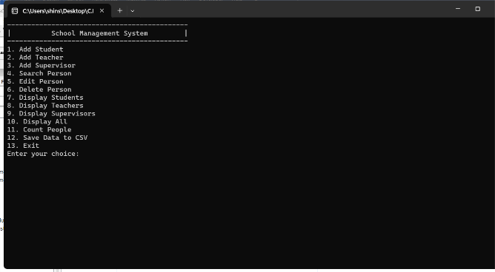This a short review of the Student Management System Project

created by the Programmers Team to assist in the management of records for students.

Add Student: This option prompts the user to enter details for a new student, which would then be added to the database. The details could include name, age, grade, and other relevant information.

Add Teacher: Similar to the first option, but for adding a new teacher to the database. The details could include name, subject taught, years of experience, and other relevant information.

Add Supervisor: This would be for adding a new supervisor to the database. The details could include name, department, years of experience, and other relevant information.

Search Person: This option would allow the user to search for a person in the database by entering some identifying information, such as name or ID. The program then displays the details of the person if they are found in the database.

Edit Person: This allows the user to modify the details of an existing person in the database. The user would likely need to provide the ID or name of the person, and then enter the new details.

Delete Person: This removes a person from the database. The user needs to provide the ID or name of the person to delete their record.

Display Students: This displays a list of all students in the database, show their details such as name, age, grade, lessons.

Display Teachers: This displays a list of all teachers in the database, show their details such as name, subject taught, and years of experience.

Display Supervisors: This displays a list of all supervisors in the database, showing their details such as name, department, and years of experience.

Display All: This displays a list of all people in the database, regardless of whether they are a student, teacher, or supervisor.

Count People: This displays the total number of people in the database. It also provides a breakdown of the number of students, teachers, and supervisors.

Save Data to CSV: This saves the current state of the database to a CSV file. This file could then be used for backup purposes, or to transfer the data to another system.

Exit: This exits the program. Any unsaved changes might be lost, depending on how the program is designed.